31.AIM:- : To draw the uml diagram for agriculture loan management system using umbrello.

USE CASE DIAGRAM:

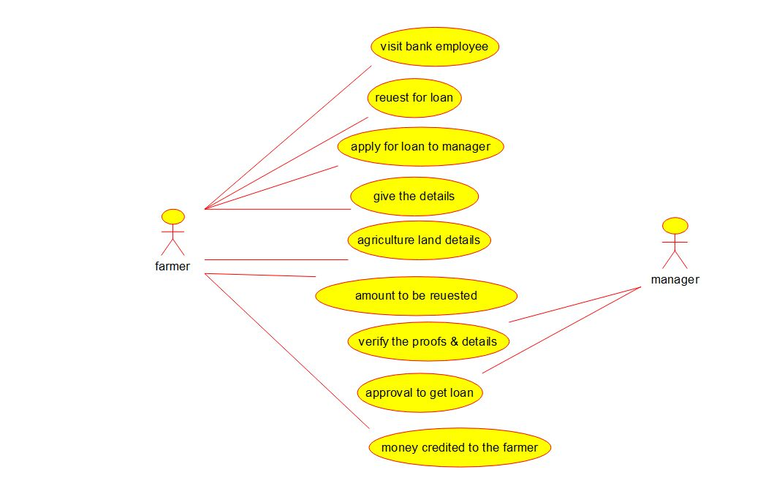

ACTIVITY DIAGRAM:

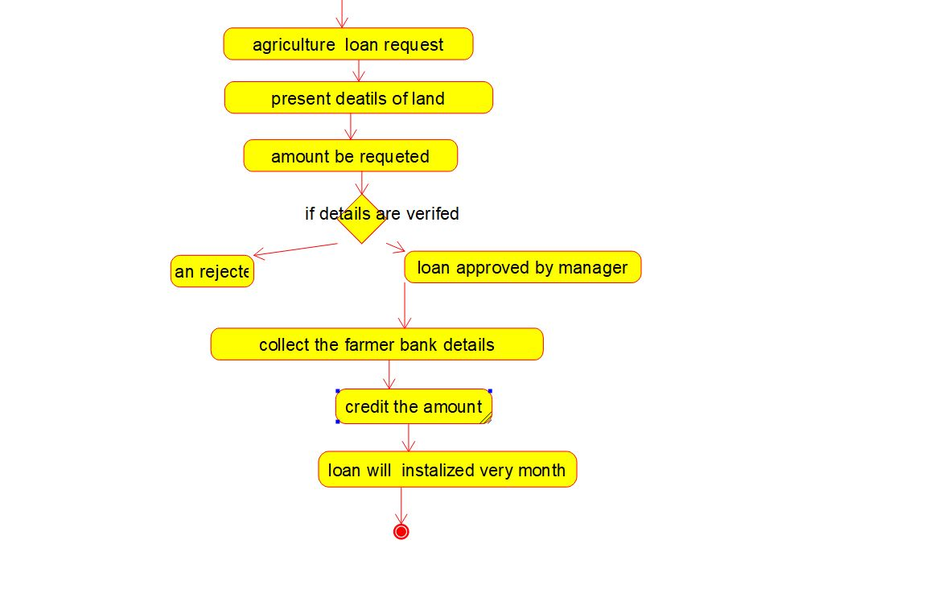

COMPONENT DIAGRAM:

